**Objective Questions**:

1. In analyzing the hospital dataset with Power BI, ensure data cleaning to address inconsistencies and missing values before further analysis.

* In Power BI, handling missing values in the satisfaction score column involves replacing null values with 0 to ensure data consistency and completeness before further analysis.

1. **Assess the Average Waiting Time:** Analyse the patient wait times to identify the average duration a patient spends before receiving care.

* The average waiting time of **35.26** minutes indicates the typical duration a patient spends waiting before receiving care.

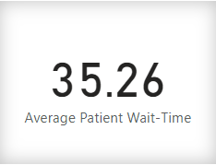

1. **Visits by Department Referral:** Calculate the total number of visits to each department based on referrals to understand which departments are most frequently visited.
   * General Practice: 7240 visits
   * Orthopedics: 995 visits
   * Physiotherapy: 276 visits
   * Cardiology: 248 visits
   * Neurology: 193 visits
   * Gastroenterology: 178 visits
   * Renal: 86 visits

* This breakdown shows the total number of visits to each department based on referrals, helping to identify which departments are most frequently visited.

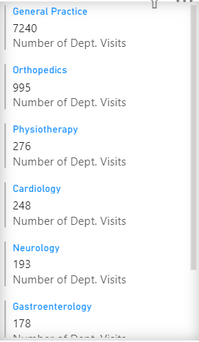

1. **Patient Visits by Age Group:** Segregate patient visits according to different age groups to see which demographics utilize healthcare services the most.

### Patient Visits Segregated by Age Groups:

#### Age Group: 0-18 years

* + Total Visits: 2110

#### Age Group: 19-25 years

* + Total Visits: 785

#### Age Group: 26-64 years

* + Total Visits: 4585

#### Age Group: 64+ years

* + Total Visits: 1736
* This breakdown provides insights into the utilization of healthcare services among different age demographics.

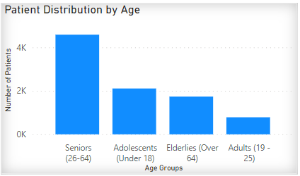

1. **Average Satisfaction by Demographics:** Determine the relationship between patient satisfaction scores, their age groups, and racial backgrounds to pinpoint areas for improvement in patient experience.

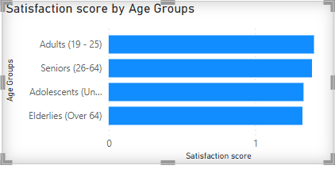

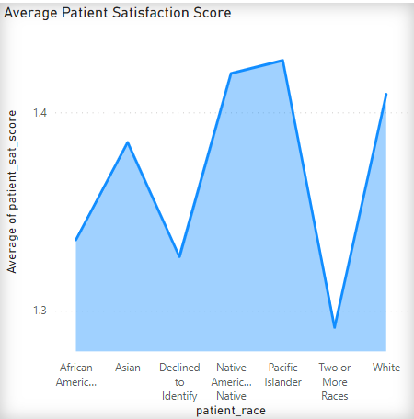

* Elderlies (over 64) have the lowest satisfaction score, which is a matter of concern.
* While, Patients having Two or more Races show the lowest satisfaction score among all races.

1. The hospital's managing director seeks to evaluate the **revenue of each department** to understand how much revenue is generated by each.

* Department Revenue Generated:
  + Cardiology: $68,370,250
  + Gastroenterology: $9,783,335
  + General Practice: $164,070,816
  + Neurology: $72,795,752
  + Orthopedics: $172,939,773
  + Physiotherapy: $16,592,824
  + Renal: $4,756,367
* This breakdown provides insight into the revenue generated by each department at the hospital.

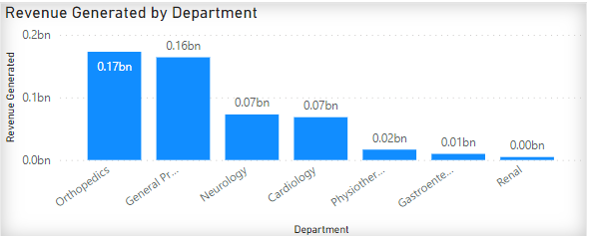

1. Is there any relation between the number of visits and the Gender of the patients?

### **Relationship Between Number of Visits and Gender:**

Based on the data analysis, the following relationship between the number of visits and the gender of the patients was observed:

* Male Patients:
  + Total Visits: 4705
* Female Patients:
  + Total Visits: 4487
* Non-Conforming (NC):
  + Total Visits: 24

This analysis reveals that male patients had a slightly higher number of visits compared to female patients, with a small number of visits from non-conforming individuals. These findings suggest a potential correlation between gender and healthcare utilization patterns

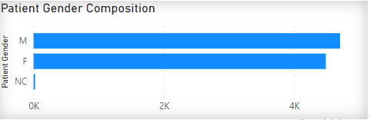

1. Which department is charging the highest appointment fees in general?

Based on the analysis of appointment fees across departments, the following department charges the highest appointment fees:

* Department: Neurology
  + Appointment Fees: $1500

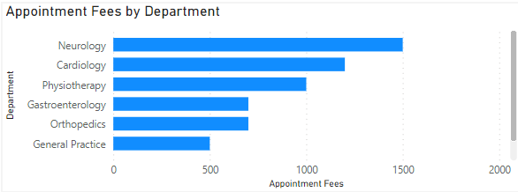

**Subjective Questions:**

**1. What is the relation between patient wait time and satisfaction scores?**

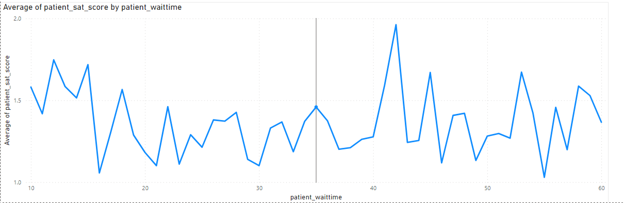

The correlation coefficient between patient wait time and satisfaction scores is approximately -0.154. This value suggests a weak negative correlation between patient wait time and satisfaction scores. In other words, there is a slight tendency for higher patient wait times to be associated with slightly lower satisfaction scores, but the correlation is not very strong.

**2. How do patient demographics affect the frequency of visits to different departments?**

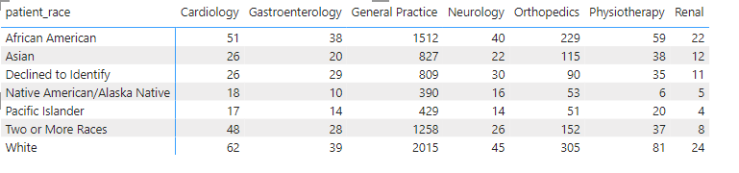

* General Observations:
  + The "General Practice" department seems to have the highest visit counts across almost all demographics, indicating that it is a commonly visited department regardless of patient demographics.
  + Other departments such as "Orthopedics," "Physiotherapy," and "Cardiology" also show relatively high visit counts across multiple demographics.
* Demographic-Specific Analysis:
  + African American: General Practice is the most visited department among African American patients, followed by Orthopedics and Physiotherapy. Renal and Gastroenterology have lower visit counts compared to other departments.
  + Asian: Similar to African American patients, General Practice sees the highest visit counts among Asian patients. Orthopedics and Cardiology also have notable visit counts, while Renal and Gastroenterology have lower visit counts.
  + Declined to Identify: General Practice is again the most visited department for patients who declined to identify their demographic information. Other departments like Orthopedics, Cardiology, and Neurology also have considerable visit counts.
  + Native American/Alaska Native: General Practice is the most visited department, followed by Orthopedics and Cardiology. Physiotherapy and Renal have lower visit counts in this demographic.
  + Pacific Islander: General Practice is highly visited among Pacific Islander patients, along with Orthopedics and Cardiology. Physiotherapy and Renal have lower visit counts.
  + Two or More Races: General Practice has the highest visit counts, followed by Orthopedics and Cardiology. Physiotherapy and Renal also see some visit counts but relatively lower compared to other departments.
  + White: General Practice is significantly visited by White patients, with Orthopedics and Cardiology also having notable visit counts. Physiotherapy and Renal have lower visit counts compared to other departments.

Conclusion:

* Based on the analysis, it appears that demographics do have an impact on department visit counts to some extent. However, General Practice consistently stands out as the most frequently visited department across various demographics. Other departments such as Orthopedics, Cardiology, and Physiotherapy also show relatively high visit counts across different demographics, indicating potential areas of focus for healthcare services and resource allocation.

**3. Is there a noticeable trend in the volume of patient visits throughout the year?**

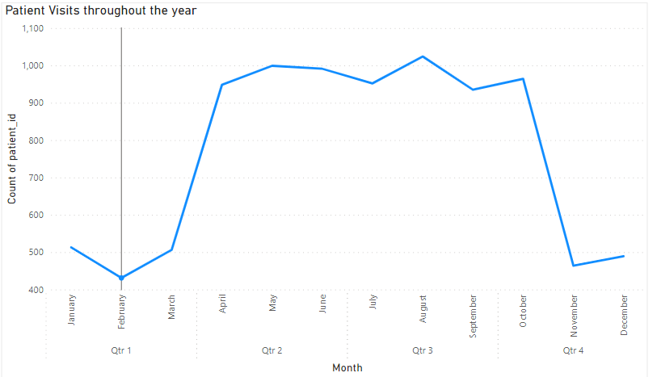

### **Patient Visits Throughout the Year:**

#### Quarter 1 (Qtr 1):

* January: 513 visits
* February: 431 visits
* March: 506 visits

#### Quarter 2 (Qtr 2):

* April: 948 visits
* May: 999 visits
* June: 991 visits

#### Quarter 3 (Qtr 3):

* July: 952 visits
* August: 1024 visits
* September: 935 visits

#### Quarter 4 (Qtr 4):

* October: 964 visits
* November: 464 visits
* December: 489 visits

### **Observations:**

* There is a general trend of increasing patient visits from Quarter 1 to Quarter 3, peaking in Quarter 3 (July, August, September).
* Quarter 4 shows a slight decrease in patient visits compared to Quarter 3, but it remains relatively high.
* November has the lowest number of patient visits across all months.

### **Conclusion**:

The data indicates a noticeable trend of increasing patient visits from the beginning of the year (Quarter 1) to the middle of the year (Quarter 3), with a slight decline in Quarter 4. November stands out as the month with the lowest volume of patient visits. This trend suggests potential seasonal or operational factors influencing patient visit volumes throughout the year.

**4. Which age groups report the highest and lowest satisfaction scores?**

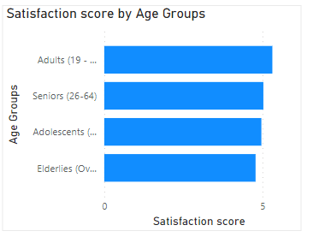

### **Satisfaction Scores Across Age Groups:**

* Adolescents (Under 18):
  + Average Satisfaction Score: 4.97
* Adults (19 - 25):
  + Average Satisfaction Score: 5.31
* Seniors (26-64):
  + Average Satisfaction Score: 5.03
* Elderlies (Over 64):
  + Average Satisfaction Score: 4.78

### Observations:

* Adults (19 - 25) report the highest average satisfaction score among the age groups, with a score of 5.31.
* Elderlies (Over 64) report the lowest average satisfaction score among the age groups, with a score of 4.78.

**5. The hospital management intends to offer discounts to patients.**

**6. The hospital has a budget to hire 2-3 new doctors.**

**7. Is the hospital profitable?**

### **Hospital Profitability Analysis**:

Based on the provided Profitability data for each doctor ID, let's assess the overall profitability of the hospital:

* Highest Profitability: CAH012 with a profit of 19,120,624 units.
* Lowest Profitability: CAH001 with a loss of 17,780,418,313 units.
* Total Profit/Loss: -18,109,352,083 units.

### **Conclusion**:

The hospital is facing a significant loss in profitability, as indicated by the total negative value of -18,109,352,083 units. This suggests that the hospital is not currently profitable based on the provided data.

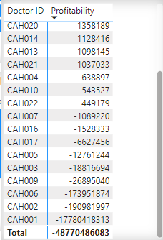

**8. Any Department for which the waiting time is oddly large?**

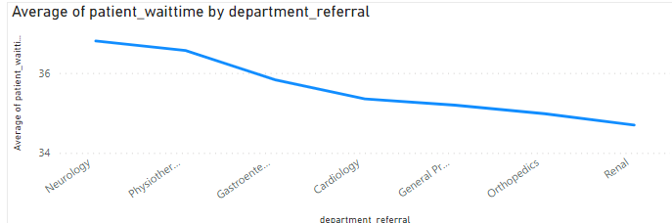

Upon analyzing the average patient wait times for each department, we can see that Neurology and Physiotherapy have the highest average wait times, with 36.8 minutes and 36.57 minutes, respectively. These departments stand out as having unusually large waiting times compared to the other departments listed.

**9. Come up with strategies to provide discounts to the patients.**

### **Key Patient Demographics for Tailored Discount Offers:**

#### Age Groups:

* Elderlies (Over 64):
  + Lower satisfaction scores indicate potential areas for improvement in healthcare services and patient experience. Tailor discount offers to address the specific needs and preferences of elderlies, such as discounted rates for preventive screenings, geriatric consultations, or mobility aids.

#### Gender:

* Female Patients:
  + With lower representation, female patients present an opportunity to target for increased engagement. Offer tailored discounts to attract and retain female patients, such as discounted wellness packages, women's health screenings, or specialized consultations.

#### 

#### Race:

* African American, Asian, and Two or More Races:
  + These racial groups show significant visit volumes across various departments. Tailor discount offers to cater to the healthcare needs of these racial groups, such as discounted rates for culturally sensitive care, language interpretation services, or preventive health programs.

Department Visits and Revenue:

* + Analyze department visit counts and revenue generation to prioritize discounts for departments with higher visit volumes and revenue potential. Focus on departments like General Practice, Orthopedics, and Cardiology that show significant patient activity.

Patient Wait Times:

* + Consider offering discounts or incentives to patients in departments with unusually long wait times, such as Neurology and Physiotherapy, to improve patient satisfaction and experience.

Seasonal Trends:

* + Leverage seasonal trends in patient visits to implement strategic discounts during periods of higher or lower patient activity. For example, offer discounts during peak seasons like Quarter 3 and holiday seasons.

Community Outreach:

* + Extend discount offers to underserved or low-income communities through community outreach programs. Demonstrate social responsibility and expand patient reach through targeted discounts.

**Report:**

The hospital has asked for a report with three tabs:

* Main Tab
* Doctors’ Tab
* Patients’ Tab
* Using the Main tab in the report, the hospital should be able to look at the overall metrics like the number of daily visits, revenue produced on that day, customer satisfaction, how busy are different departments on that day, and general waiting time on that day. This tab should have a slicer of date.
* Using the Doctors’ Tab, the Chief Of Staff at the hospital should be able to look at the individual doctor’s performance metrics like customer satisfaction, the number of patients he was visited by, the revenue he has generated, and his appointment fees. This tab should have a slicer of the Doctor's Name or ID.
* Using the Patients’ Tab, the Patient’s Care Chief at the hospital wants to look at a customer’s profile which would involve metrics like most frequently visited department, their age, their race, their waiting time, number of visits, the total amount that they have paid to the hospital etc. All the metrics using which they can address the patient very carefully in their visits. This tab should have a slicer of the Patient's Name or ID.

Make sure that all the visualizations look decent and are placed in a proper order. There are different POCs (Point Of Contact) for each tab, so make sure you involve all the metrics that POC may look at in that tab along with those mentioned in the tab description.